SAP Document

To Start SAP Services :--

1.Login into the server

2. SAP scripts will be under /root/scripts/ below is the screenshot for reference



3. First we have start the hanadb and then sap services.

Commands to run the hanadb

**./hanadbstart.sh**

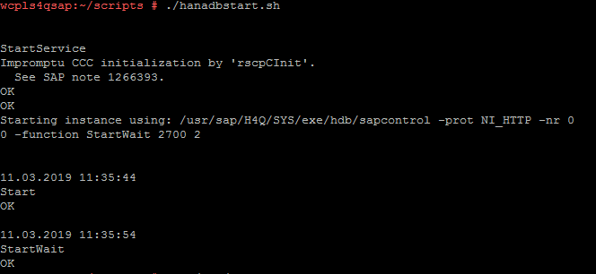

4. To check hana is running or not first we have cat the /etc/passwd to find hanadb user.

**cat /etc/passwd** then we will get the list of users as below :--

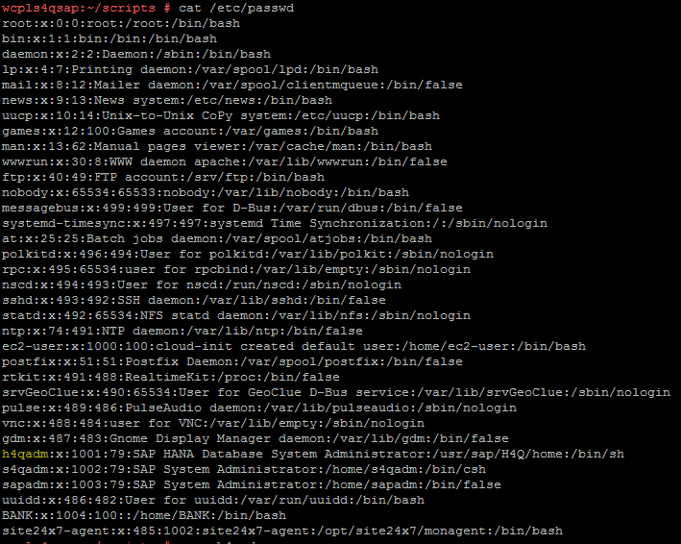

h4qadm is the hana database user then switch to the user by using **su - h4qadm**

5) Then go to **cd /usr/sap/hostctrl/exe** then execute the below command

**./sapcontrol -nr 00 -function GetSystemInstanceList**

Will see the list of lines as below

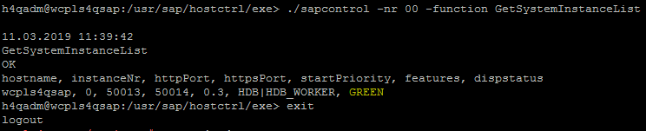

Below are the status and representation

GREEN represents HANADB is working fine

GREY represents HANADB is not running

YELLOW represents It is not working some issue with application(need to inform customer ).

6.Once confirmed that Hanadb is running fine then start the SAP services

Same as go to **cd /root/scripts/**

Then execute the script **./ s4start.sh** to start the sap services

7.In order to check whether SAP services running on or not we have switch to sap user we can find the sap user by using **cat /etc/passwd**

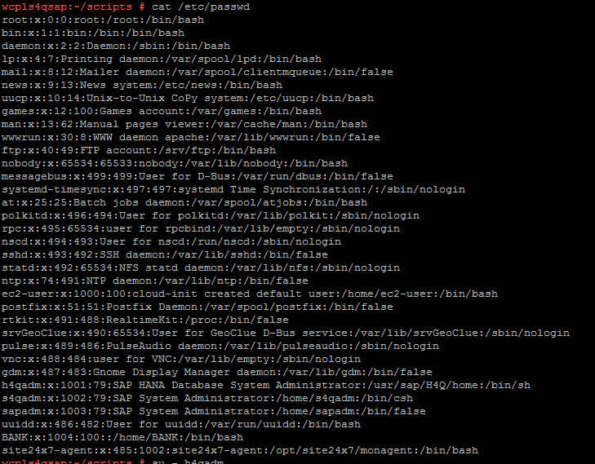

s4qadm is the sap user then switch to user by using the command **su - s4qadm**.

8.Then go to **cd /usr/sap/hostctrl/exe** execute the following command

**./sapcontrol -nr 01 -function GetSystemInstanceList**

Below is the screenshot for reference:--

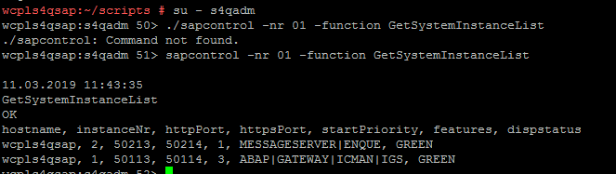

Below are the status and representation

GREEN represents sap is working fine

GREY represents sap is not running

YELLOW represents It is not working some issue with application.(need to inform customer ).

**Stop SAP services:--**

1.While stopping first we have to stop the sap services by using the following command

**./s4stop.sh**

2.After stopping the sap we need to stop the db by using **./hanadbstop.sh**